

**SYSTEM OVERVIEW**

*Sample Text here sample text here sample text here sample text here sample text here sample text here sample text here sample text here sample text here sample text here sample text here sample text here sample text here sample text here sample text here sample text here sample text here sample text here sample text here sample text here sample text here sample text here sample text here sample text here sample text here sample text here sample text here sample text here sample text here sample text here sample text here sample text here sample text here sample text here sample text here sample text here sample text here sample text here sample text here sample text here sample text here.*

**GENERAL INFORMATION OF SYSTEM**

*Sample Text here sample text here sample text here sample text here sample text here sample text here sample text here sample text here sample text here sample text here sample text here sample text here sample text here sample text here sample text here sample text here sample text here sample text here sample text here sample text here sample text here sample text here sample text here sample text here sample text here sample text here sample text here sample text here sample text here sample text here sample text here sample text here sample text here sample text here sample text here sample text here sample text here sample text here sample text here sample text here sample text here.*

**SYSTEM PREFACE**

*Sample Text here sample text here sample text here sample text here sample text here sample text here sample text here sample text here sample text here sample text here sample text here sample text here sample text here sample text here sample text here sample text here sample text here sample text here sample text here sample text here sample text here sample text here sample text here sample text here sample text here sample text here sample text here sample text here sample text here sample text here sample text here sample text here sample text here sample text here sample text here sample text here sample text here sample text here sample text here sample text here sample text here.*

**User Manual - Process**

**CEU Purchasing System**

Process System Flow Chart

Request Item(s)

Head/Recommending for approval

User

Approved

*No*

*User Response*

Admin assign to canvasser or forward to requisitioner

Canvasser

Admin assign to budget

User

User

Budget Approved?

*No*

*User Response*

Above 250K?

*Yes*

Above 1M?

*Yes*

**SYSTEM FLOW DESCRIPTION**

*User will file a request and it will be forwarded to the head of his/her department. Head department will then assign it to the recommending department if necessary. Etc etc..*

**Setting up the system**

Before anything else, you need to setup all the settings of the system so you need to go to the settings menu. *You need to add first Department and Branches settings before adding a user’s. You also need to add the product Category before adding the Products.*

**General Settings**

General settings page where you can set the Company Profile, Purchase Order, and the Dashboard.

**Email Messages**

The Email Messages page where you can set the content of the emails on every process. Once you click the “Edit” button, there you can see the content of the email on that process. Please fill up the “Subject” and the “Message” Content. There are default emails that has been stored but you can edit those. There are shortcodes that you need know to make it dynamic. See shortcodes below.

Shortcodes

* [name_from] – This will replace to the name of the user where the process came from.
* [email_from] – This will replace to the email of the user where the process came from.
* [name_to] – This will replace to the name of the user whom the process to come.
* [email_to] – This will replace to the email of the user whom the process to come.
* [request_number] – This will replace the request number.
* [request_name] – This will replace by the name of the request.
* [urgency_level] – This will replace by the priority label of the request
* [message] – This will replace by the message of the sender.
* [po_num] – This will replace by the purchase order number.
* [item_name] – This will replace by the product name or item name.

**Users**

Users page where you can add, edit, deactivate and change the password of the users. Before adding a user, please make sure that the Branch and The Department is already setup.

* **User Type**: There are 8 kind of user type on this system enumerated below.
  + **Administrator** – The administrator of this system which have the main user doing this purchasing process.
  + **General User** – The User or the employee of the company.
  + **Canvasser** – The canvasser is the person who has his role is to canvass the product or item.
  + **Budget** – The budget department is the user type who approve the budget.
  + **VP Administration and Accounting** – The role of this user is to audit the Purchase Order.
  + **Purchasing Committee** – This User type has no role on this system, we just need to register a person on this user type for the email purposes to approve the huge amount of budget.
  + **Board** – Board department is just like the Purchasing Committee however it only notify if the budget is larger than what’s the purchasing committee can handle.
  + **Property Department** – This User type is the one who handle the inventory of the products or item.
* **Branch** – Select which branch the user belongs to.
* **Department** – Select which department the user belongs to.
* **Department Head** – Only check this checkbox option if the user you want to add is the head of its department.
* **First name** – First name of the person or user.
* **Last Name** – The Last name of the person or user.
* **Phone** – Contact number of the user
* **Email** – Email address of the user.
* **Password** – Enter the desired password you want the user to use. You need to click the “**activate”** button after you add the user. However, user can also defined there own password because after you add the user, there will be an email confirmation for the user where they can input a new password for their own.

**User Group**

User group has only fixed 8 user type. You can only edit the description on this page. The description will appear when you add or edit the user as “User Type”.

**Department**

This page where you can add, edit and delete the User department. This will also appear when you add a user so this need to setup first before adding the user.

**Branches**

This page where you can add, edit and delete the branches of the company. This will appear also when you add a user where you can select which branch they are. This will need to setup first before adding a users.

**Supplier**

This page where you can add, edit and delete the supplier. The supplier will appear in the canvasser page where they can select the supplier they have canvassed. Canvasser can also put a supplier that is not added here.

**Products**

Admin can also add the common products here so that the requisitioner can only select the product they want to request. If the products is not exists, they can also put a custom product.

**Product Category**

Admin can add a product category on this page. The category has only have a second level. This will also setup first before adding a product because this will appear when you add a products.

**Request Category**

Request category is for admin purpose. Admin can select which category is the request belongs to. These will appear when the admin assign the request to canvasser.

**Purchase Order**

* You can see in this page all the generated purchase order. The “Update” button will be disabled once it is already approved by the VP Administration and Accounting.

**Request New**

- Creating a new request can be done by any of the user type. Creating a new request has a 3 steps.

Step 1:

1. Request Name – Name of your request
2. Purpose – Purpose of your request
3. Priority Level – Normal(5 days) or Urgent(3 days)

Step 2:

1. Click “Add Item” button. See Figure 1.0
2. Select and search the product you want. These products can be added in the settings. If you or the user can’t find the product they want just type the product and hit enter. See figure 1.1
3. Click the “Add” button. See figure 1.1
4. Input the product description and the quantity.
5. There is a “remove item” button if you want to remove it. See figure 1.0.
6. There is an “attachment” button if you want to add an attachment if this product or item. The file accepted are “gif,jpg,png,zip,zipx,rar,7z,pdf,doc,docx,txt,odt”. See figure 1.0
7. Attachment window where you can upload, remove and download the attachment. See figure 1.2
8. Click next when you’re done.

Step 3:

Preview of your request. Click File Request when you’re done. You can click “Previous” button when you forgot something. The request will be automatically forwarded to head of your department.

*Figure 1.0 – Step 2*

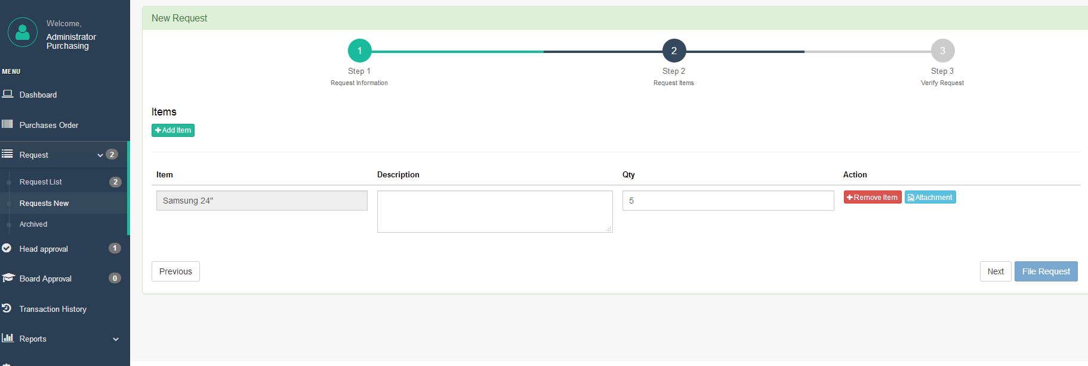

*Figure 1.2 – Attachment window*

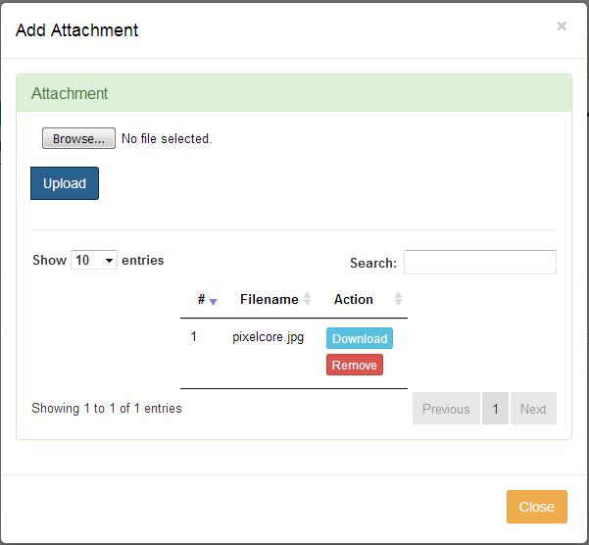

*Figure 1.1 – Add item window*

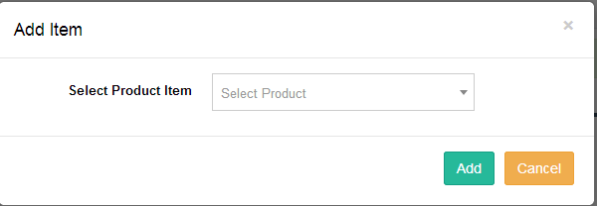

**Head Approval**

Once Request received by the head approval, the head will then click the “Recommending approval” button under action column then you will be redirected to recommending approval page. See figure 2.0

* Assigning item to head users – You can assigned the any of the items to any of the head department if necessary. If not, you can just assigned it you yourself. Just select the Head user from the left side section then select the item(s) in the middle section you want to assign to the selected user then click the “assign” button. The assign items now available in the right side portion. See figure 2.0.
* Deleting assigned head user – If you have assigned it to the wrong head user, you can also delete it. Just select the head user at the left side portion then click the “Delete as Approving Officer”
* Review each items – After assigning to the head users, you can click the “back” button to go back to the list of head approval request.
* Approving and Denying Items – Click the “View Items” button to view the items that is assigned to you. See figure 3.1. You can also see the items that is assigned to the other head (see *Assigned To* column). You can approve and deny only the item assigned to you. When you deny, it will notify the requisitioner. Once the requisitioner will response, it will appear the response to the *Requisitioner Note* column. All the items should be approved by all the recommending officer before it will be forwarded to the admin.

*Figure 2.0 – Recommending Approval Page*

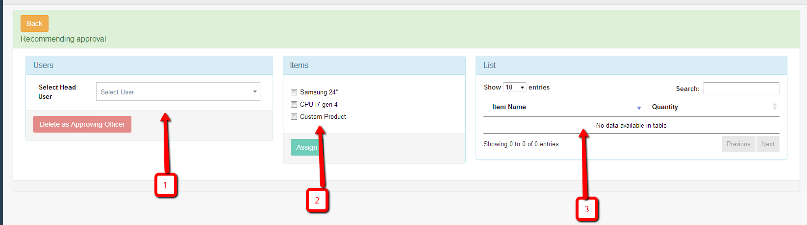

1. List of all Head department Users
2. List of items which you can check if you assigned it to the selected head user.
3. List of selected items of the selected user

**Admin Assign to Canvasser**

* Once approve by the Head/Recommending Officer, the admin can now forward it to requisitioner if they have clarification or forward it to Canvasser if it is good to go. See figure 3.0. When you forward it to canvasser, the popup window ask you the request category and the canvasser you want it to assign.

*Figure 3.0 – Request list*

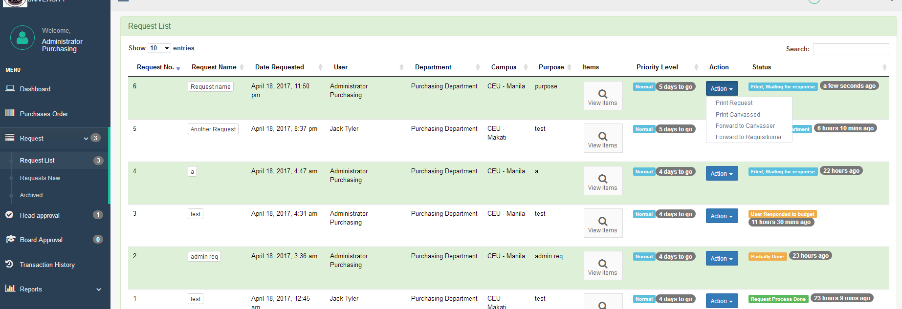

*Figure 2.1 – Head Approval Item Window*

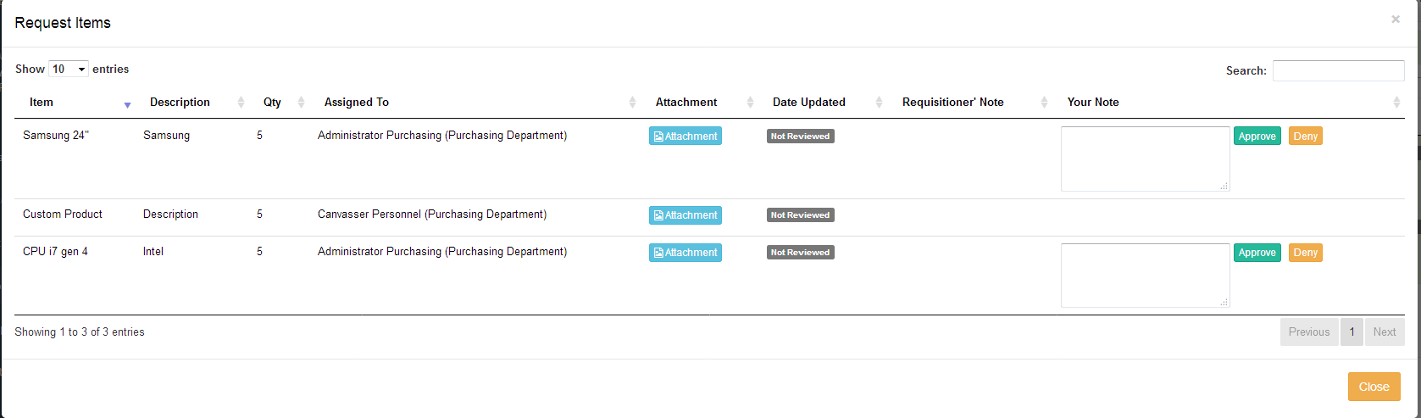

**Canvasser**

Update items - Once it is forwarded to canvasser, the canvasser click the “update items” in the action button to update the items they canvassed and it will be redirected to the **“Product / Items”** page. See figure 4.0

* Add Item – Canvasser can add items if they want to decide. They only need to click “Item Button” like what the requisitioner did when they request an item. See **Request New** in **step 2** Section at page 8.
* Canvassed Items – Canvasser can add a record of all the prices they canvassed on each item. Just click the “canvassed” button then it will redirect to the canvassed items. See figure 4.1
  + Add Item – You can add any different prices of the item from different supplier
  + Update Selected Item – Once you have selected the final item, choose the radio button of your choice and click “update Selected Item”. This will then be appeared in the **“Product / Items”** page automatically.
  + Edit – You can edit the canvassed items. After updating the canvassed items, make sure that you need to click the “Update Selected Items” again to update selected item.
  + Delete – You can delete the canvassed item if you want and again, make sure that you click again the “update Selected Item” to update the prices of the selected items.
* Update – Once you click the “update” button in the Product/Items page. Canvasser now be able to forward it back to admin.

Print Request – Print the final canvassed items

Print Canvassed – Print the Canvassed Items

Return to Requisitioner – Return the request to requisitioner if there are clarification, or forward to admin if there were no.

*Figure 4.0 – Products/Items*

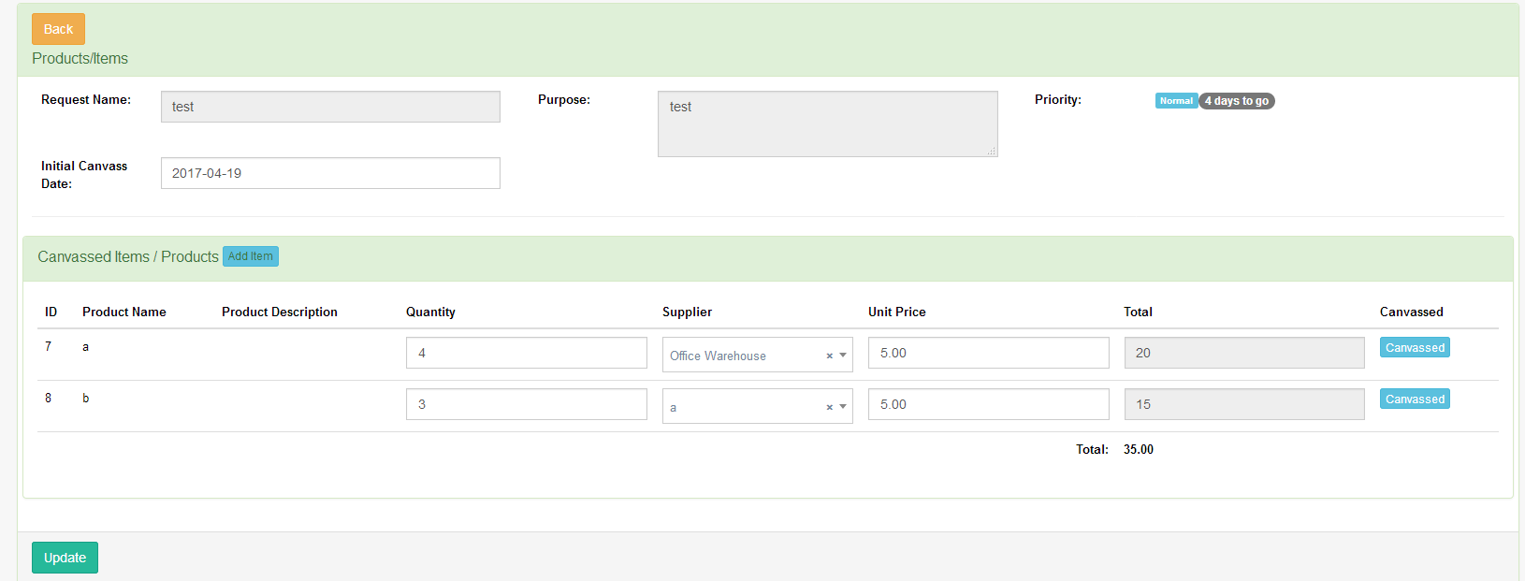

**Admin Assign to Budget**

*Figure 4.1 – Canvassed Items*

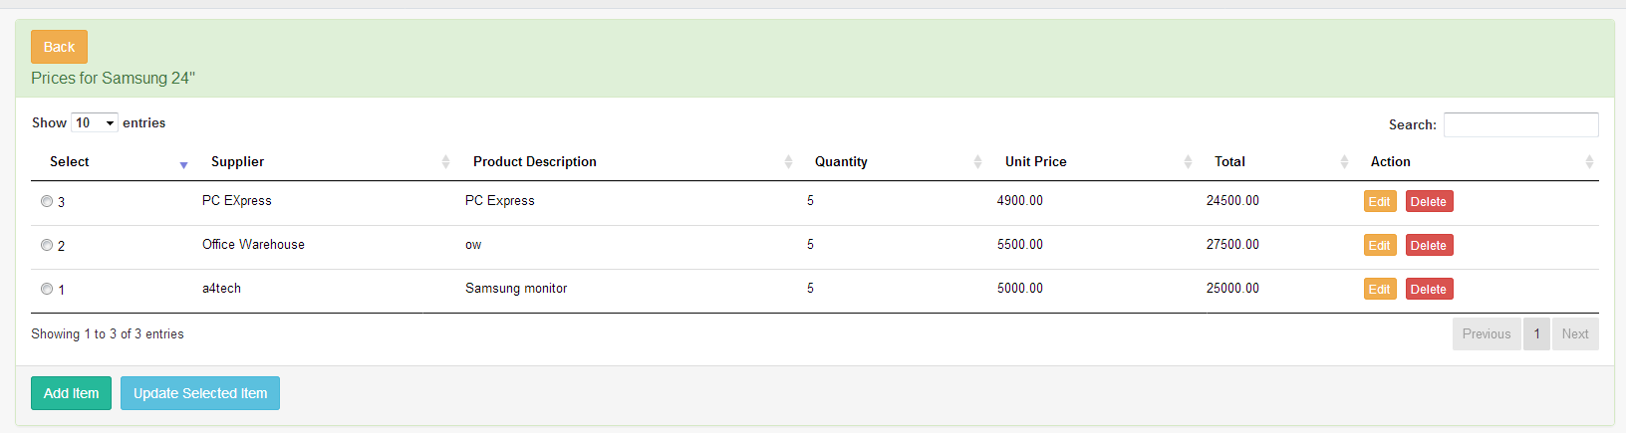

Print Request – Admin can print the final request items selected by the canvasser.

Print Canvassed Items – Admin can print all the canvassed items.

Return to Canvasser – Admin can return the request to canvasser if there were something wrong.

Assigne to Budget – Admin will assign the request to budget if it is good to go.

**Budget**

Print Request – Budget can print the final request items selected by the canvasser.

View Message – View message/note from admin

Approve – Approve the request. If Total amount is less than 250k, it will go directly to the admin. If the total amount is greater than 250k and less than 1M, it will notify the board, then approved by the admin. If the request total amount is greater than 1M, it will notify the purchasing committee and board before the admin can approve it.

Deny – Deny a request (return to requisitioner).

**Board**

Print Request – Print the final item request

Approve – Approve the request

Deny – Deny a request(return to requisitioner)

**Admin**

Generate PO

* When the budget or board approved the request, the admin now can generate PO. Just click the “Generate PO” button under the Action button of the corresponding row of the request.
* Generate PO Page – After clicking the “Generate po” button, it will be redirected to the page where you can generate the PO on each supplier. See figure 5.0
* Each supplier will generate purchase order. After selecting the Supplier which you want to generate the PO. Please fill up the required fields then click update. The PO will then be forwarded to the selected VP Administrator & Accounting in the Approved by field.

*Figure 5.0 – Generate PO*

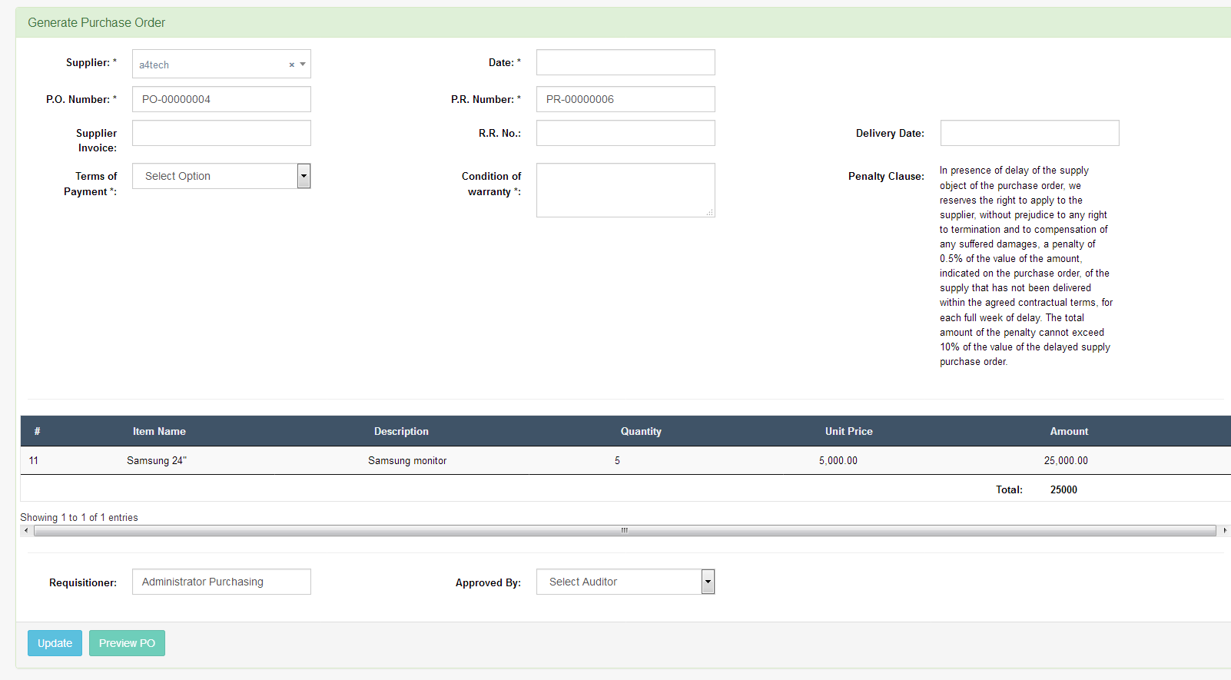

* You can enter manually the PO number and PR number. Once you decided to start the auto increment in the certain number, just go to [www.yourdomain.com/settings/console/](http://www.yourdomain.com/settings/console/). See figure 5.1. You can set the number of PO and PR where you want to start.

*Figure 5.1 – Console*

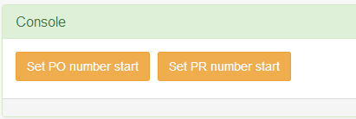

* Partially Done – Admin can Click the “Partially Done” button. If the VP Administration & Accounting approve the PO, all the Items approved, will appear in the window. See figure 5.2. After clicking the “Done” button, it will now appear in the property and waiting when it is delivered.

*Figure 5.2 – VP Admin & Accounting Approved Items*

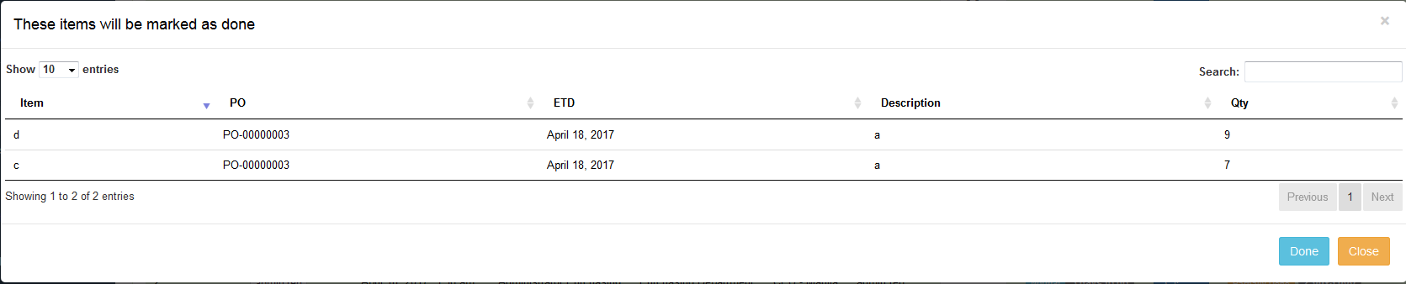

**VP Administration & Accounting**

Approve the purchase order generated.

**Property**

Request Done – It shows all the PO currently on delivery. They can received the items when it is delivered.